**------- Hypertext markup Language---**

1. Self-closing tags
2. 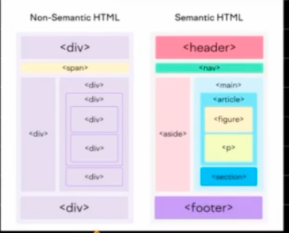  
   Semantic - semantic gives a meaning to a html page
3. -----------CASCADING STYLE SHEET---------------

CSS gets applied in the sequence or on the order they are written or included in the HTML, inline is the most closest one which gets applied.

1. *(universal selector) - is used to select all elements.
2. .className {space} . className – to select the descendant (any child)
3. div>p – to target direct child of div
4. input[attribute value] also a selector
5. .className.className – targets element having both the classes
6. <head>  
     <link rel="stylesheet" type="text/css" href="theme.css">  
     <link rel="stylesheet" type="text/css" href="print.css" media="print">  
   </head>   
   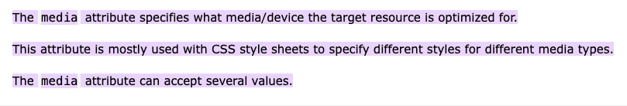
7. A black background with text

   Description automatically generated  
   We are doing lazy loading of CSS files depending on the targeted device using media attribute.